1) As a user, I want a cashless transaction so I am able to use a credit card to pay for the books.

2) As a customer, I want to able to contact the seller so I can ask more about the book.

3) As a customer, I want to view the product of books so I can know the details of the book product.

4) As a buyer, I want to search the product of books so I can see the types of book products.

5) As a user, I want to order the books so I can add the book item to the cart.

6) As a purchaser, I want to buy the books so I can make an order confirmation.

7) As a user, I want to see reviews so I can make my option of books better.

8) As a purchaser, I want to know how much time it takes to transport books so I know how much time I need to wait.

9) As a buyer, I want to know the price of books so that I can narrow down my book list.

10) As a customer, I want to submit my review and rate to the book trading system.

11) As a buyer, I want to see if there is a discount or free shipping so that I can reduce the purchase cost.

User Story Mapping

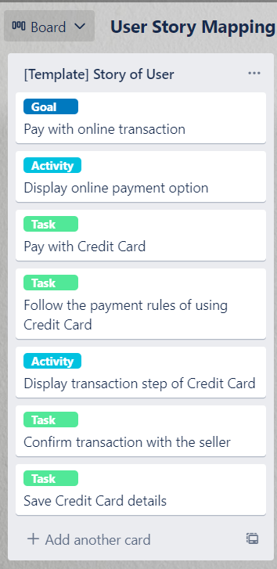

User Story 1

User Story Mapping

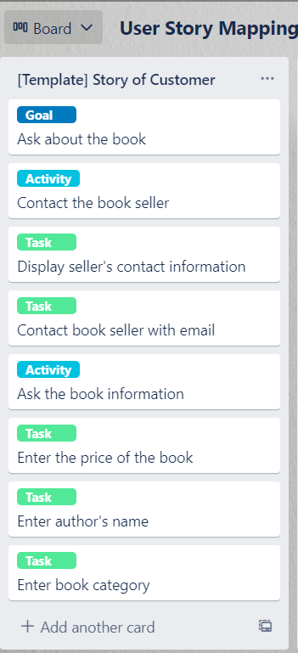

User Story 2

User Story Mapping

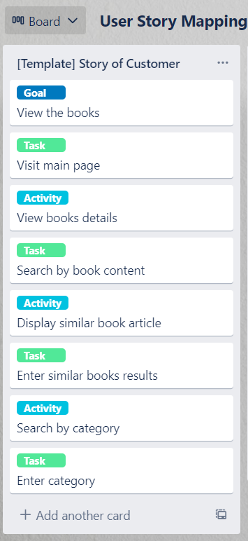

User Story 3

User Story Mapping

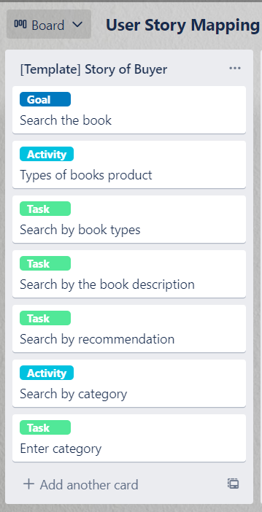

User Story 4

User Story Mapping

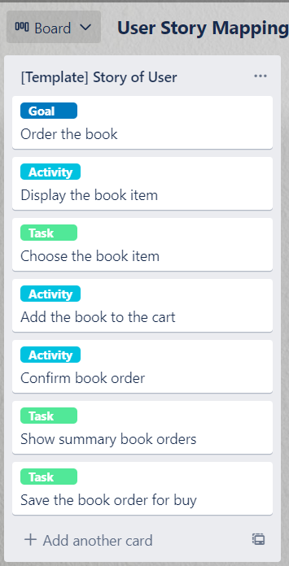

User Story 5

User Story Mapping

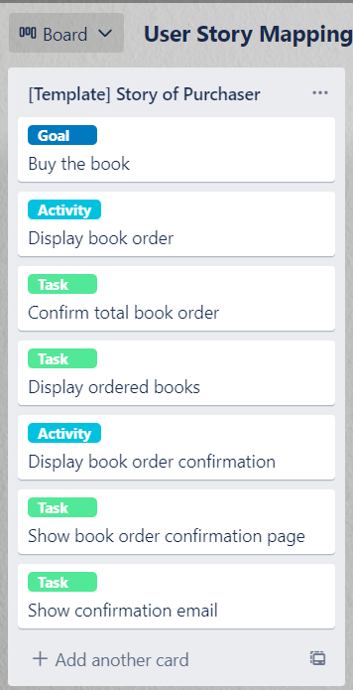

User Story 6

User Story Mapping

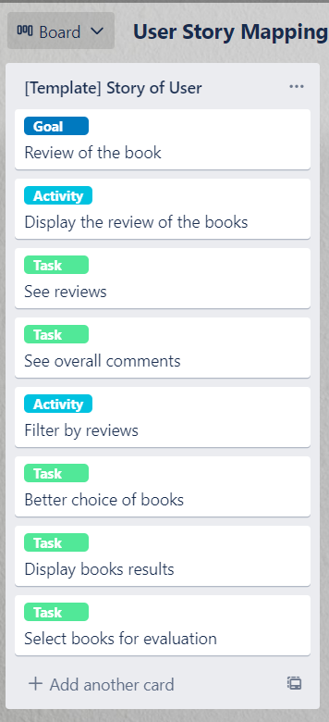

User Story 7

User Story Mapping

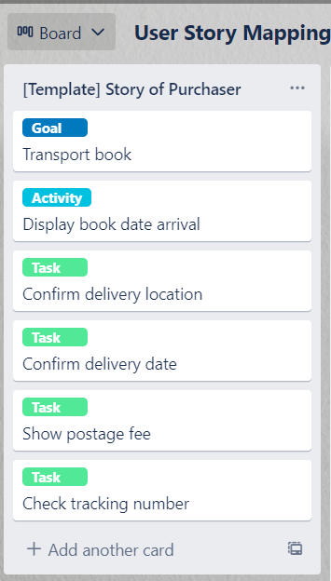

User Story 8

User Story Mapping

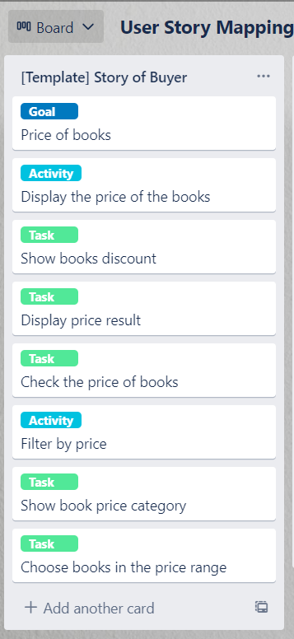

User Story 9

User Story Mapping

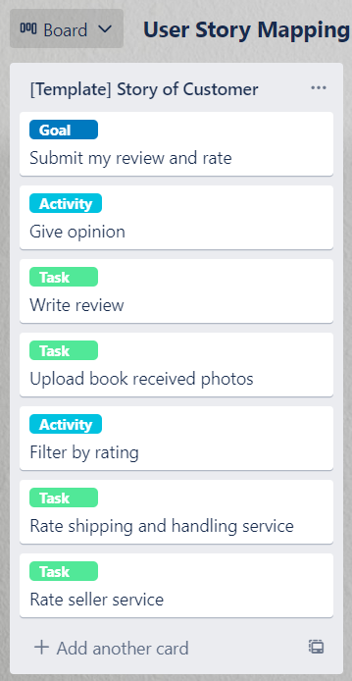

User Story 10

User Story Mapping

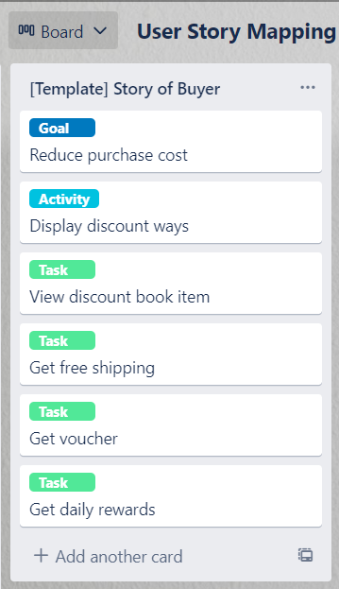

User Story 11